Project Management Documentation: Gravity Books Data Warehouse Solution
This document serves as a validation of the collaborative efforts and contributions made by the team during the development of the **Gravity Books Data Warehouse Solution**. Below, we provide an overview of the project management process, including screenshots of key milestones, task assignments, and pull request merges.

1. Project Overview
The Gravity Books Data Warehouse Solution was developed to track customer orders, manage book details, and analyze sales performance. The project was divided into seven major tasks, each assigned to different team members. The tasks included:
- Conceptual Modeling and ERD Creation
- DWH Modeling and Schema Creation
- Explanation of the Approach
- DDL Creation and Constraints Implementation
- ETL Process Using SSIS
- Cube Creation Using SSAS
- Visualization Using Excel and Power BI

2. Task Assignments and Progress
The project was managed using a Kanban board, which tracked the progress of each task. Below are the key tasks and their statuses:

Task Assignments
Task | Assignee
KAN-1: Conceptual Modeling and ERD Creation | Asmaa Moayad
KAN-2: DWH Modeling and Schema Creation | Roa'a Badawy
KAN-3: Explanation of the Approach | Roa'a Badawy
KAN-4: DDL Creation and Constraints Implementation | Abdelrahman Shear
KAN-5: ETL Process Using SSIS | Mohammed Alsamadoni
KAN-6: Cube Creation Using SSAS | Asmaa Moayad
KAN-7: Visualization Using Excel and Power BI | Ahmed Ayman
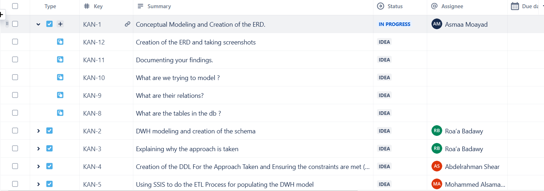

3. Collaborative Workflow
The team used GitHub for version control and collaboration. Below are some key screenshots that demonstrate the collaborative workflow:

3.1 Pull Request Merges
- Mohamed's PR Merge (KAN-5):
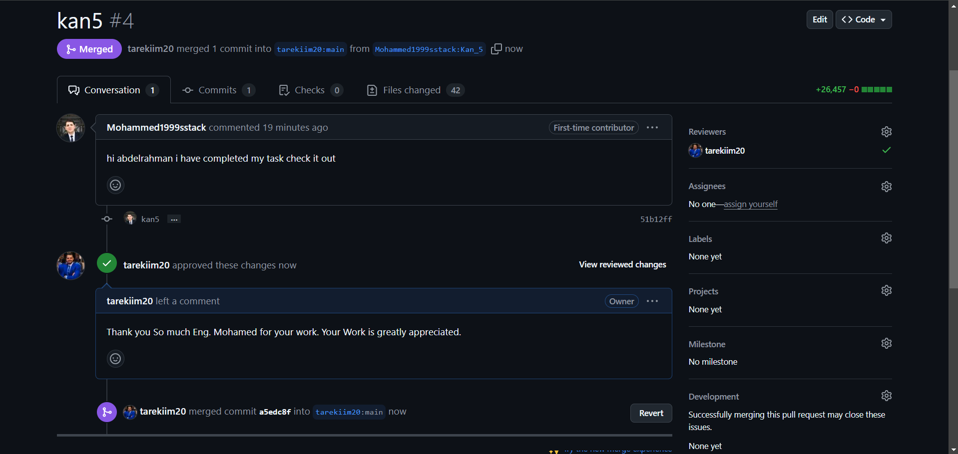
- Description: Mohamed completed the ETL process using SSIS and submitted a pull request, which was reviewed and merged by the project owner.

- Roa'a's PR Merge (KAN-2 & KAN-3):
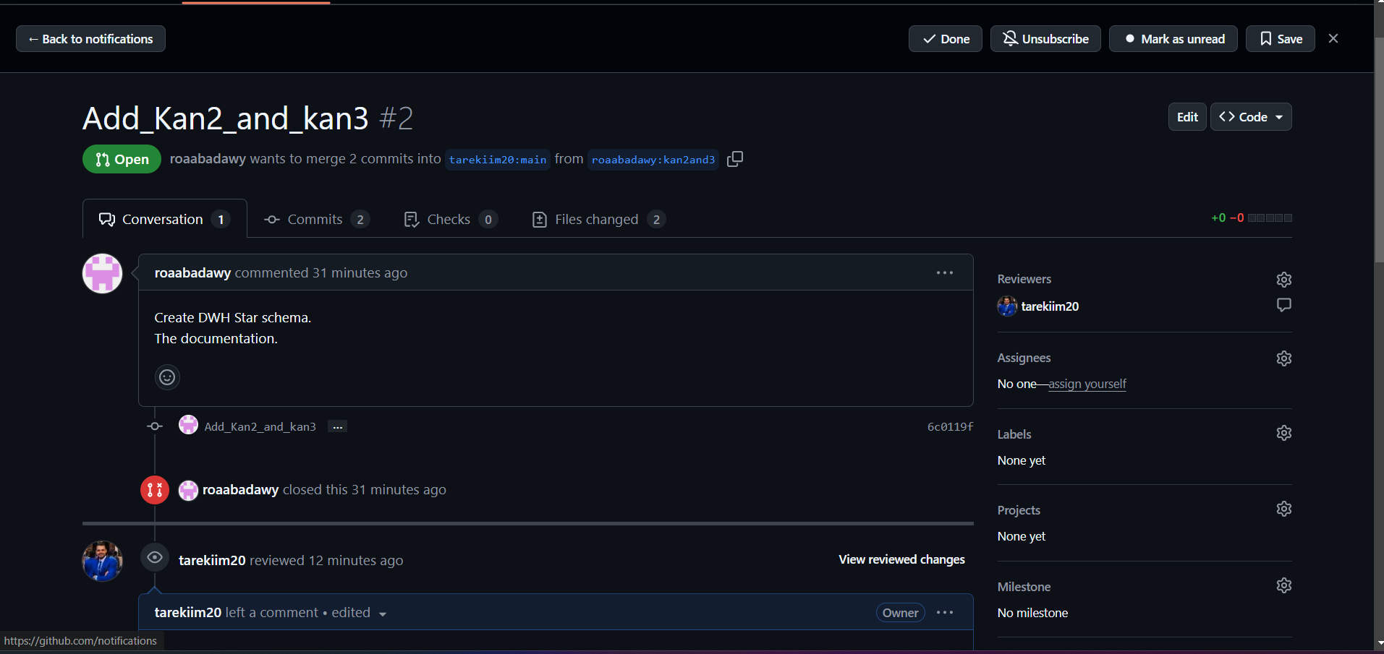
- Description: Roa'a completed the DWH modeling and schema creation, and her pull request was successfully merged.

- Asmaa's PR Merge (KAN-6):
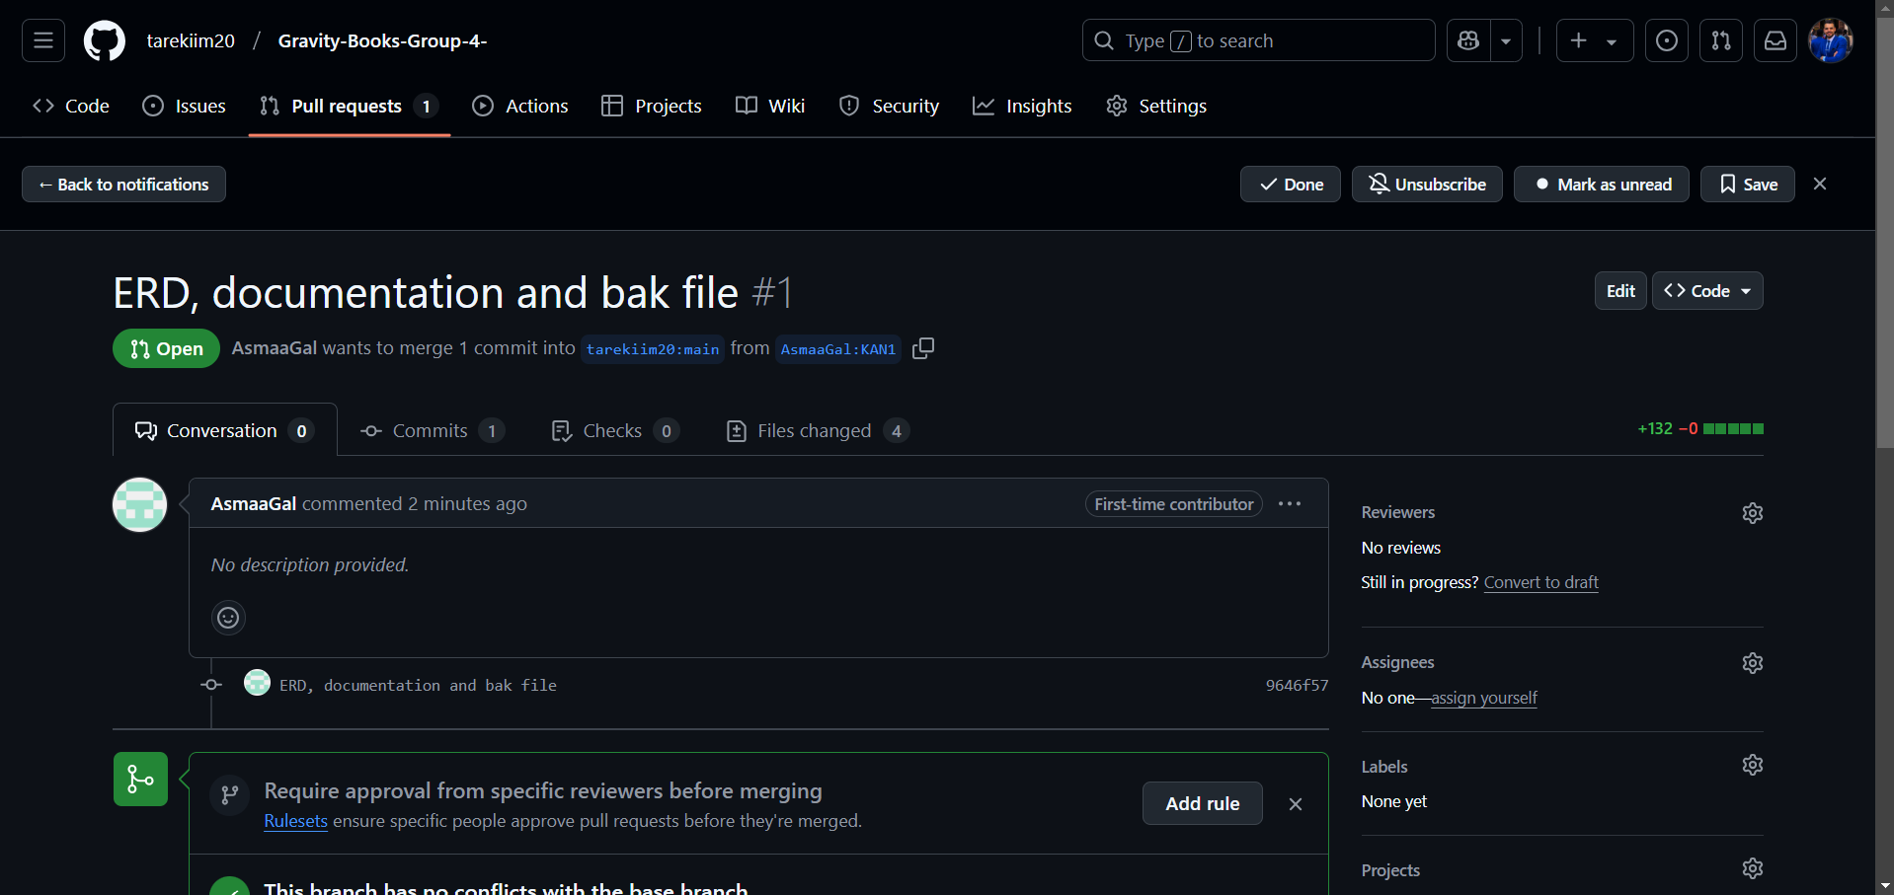
- Description: Asmaa completed the cube creation using SSAS, and her pull request was approved and merged.

3.2 Kanban Board Progress
- Initial Kanban Board:
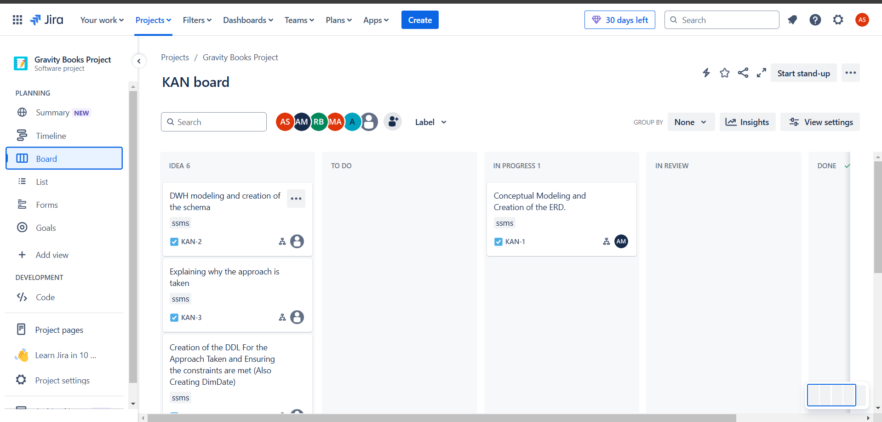
- Description: The initial Kanban board shows the tasks in the IDEA and IN PROGRESS stages.

- Final Kanban Board:
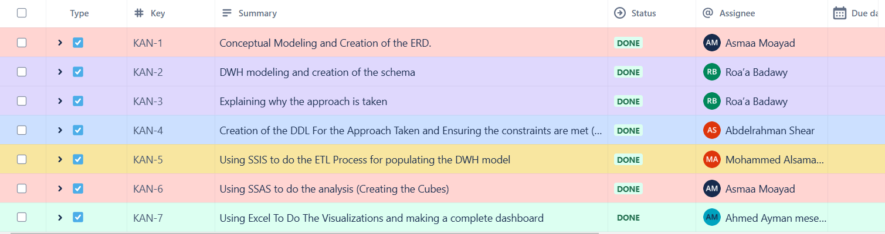
- Description: The final Kanban board shows all tasks marked DONE, indicating the successful completion of the project.

3.3 GitHub Network Graph
- GitHub Network Graph:


- Description: The network graph shows the collaboration between team members, with branches and merges clearly visible.

4. Key Milestones
Below are some key milestones achieved during the project:

4.1 Conceptual Modeling and ERD Creation (KAN-1)
- Assignee: Asmaa Moayad
- Screenshot: 
- Description: Asmaa created the conceptual model and ERD for the Gravity Books database.

4.2 DWH Modeling and Schema Creation (KAN-2)
- Assignee: Roa'a Badawy
- Screenshot: 
- Description: Roa'a designed the DWH schema and documented the approach.

4.3 ETL Process Using SSIS (KAN-5)
- Assignee: Mohammed Alsamadoni
- Screenshot: 
- Description: Mohammed implemented the ETL process using SSIS to populate the DWH.-

5. Conclusion
The Gravity Books Data Warehouse Solution was successfully completed through the collaborative efforts of the team. Each member contributed to different tasks, ensuring the project's success. The screenshots provided in this document validate the team's collective work and contributions.

Team Members and Contributions
- Asmaa Moayad: Conceptual Modeling, ERD Creation, Cube Creation (SSAS)
- Roa'a Badawy: DWH Modeling, Schema Creation, Explanation of Approach
- Abdelrahman Shear: DDL Creation, Constraints Implementation
- Mohammed Alsamadoni: ETL Process (SSIS)
- Ahmed Ayman: Visualization (Excel and Power BI)

This document serves as a validation of the team's collaborative efforts and successful completion of the Gravity Books Data Warehouse Solution.

